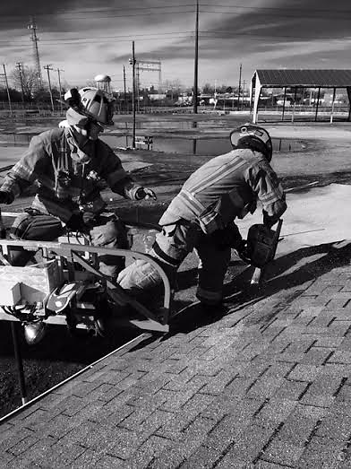
Fire Service Mortar: The Critical Role of the Company Officer
Presented by Lt. Jarrod Sergi
October 22nd, 2016 0900-1500
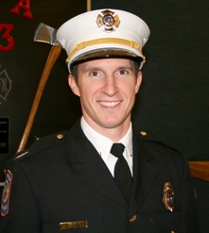
1804 S. Church St. Smithfield, VA 23430

Course Description:
This course will provide the essential tools needed to lead from the front as a Company Officer. In this program the instructor will bring previous military leadership experience as well as experience in his current role as a Company Officer. Key concepts discussed will be preparation, leadership traits, team building, mentoring, training, conflict resolution and more. Fire Service Mortar is meant to inspire action and give you tools today that will produce results in your company, your station, and your department.

There is no charge for this course and seats are limited. Please register below:
https://www.eventbrite.com/e/fire-service-mortar-the-critical-role-of-the-company-officer-tickets-27109916490

Trial by Fire
Stomp Out Mediocrity

